

18/10/2017

Ray’s Rental

By Antreas Christofi, Alexander Harrison, Callum Flanagan, Lewis Frater, Rebecca Clarke.

[Introduction 2](https://docs.google.com/document/d/1NwHo2UTIMuzlcYSaaQiniYDEdrc8DTGT0_SmAPsDSbE/edit#heading=h.9iclg7h78s31)

[**Description of the problems with the current paper based system at Ray’s Rentals 2**](https://docs.google.com/document/d/1NwHo2UTIMuzlcYSaaQiniYDEdrc8DTGT0_SmAPsDSbE/edit#heading=h.r3ucvnk79qhk)

[**System requirements for a proposed new computerised database system 3**](https://docs.google.com/document/d/1NwHo2UTIMuzlcYSaaQiniYDEdrc8DTGT0_SmAPsDSbE/edit#heading=h.cgvwwp4tqyhc)

[What data enquiries and management reports are and the different types of management reports that are used 4](https://docs.google.com/document/d/1NwHo2UTIMuzlcYSaaQiniYDEdrc8DTGT0_SmAPsDSbE/edit#heading=h.u0y1azicl0h0)

[**Useful data enquiries and management reports for Ray’s Rentals 5**](https://docs.google.com/document/d/1NwHo2UTIMuzlcYSaaQiniYDEdrc8DTGT0_SmAPsDSbE/edit#heading=h.g2kf09sowke)

[Types of data and data enquiries 5](https://docs.google.com/document/d/1NwHo2UTIMuzlcYSaaQiniYDEdrc8DTGT0_SmAPsDSbE/edit#heading=h.bw7m2x99xmcv)

[Discrete/Categorical data 5](https://docs.google.com/document/d/1NwHo2UTIMuzlcYSaaQiniYDEdrc8DTGT0_SmAPsDSbE/edit#heading=h.qcz0me4x923x)

[Continuous Data 5](https://docs.google.com/document/d/1NwHo2UTIMuzlcYSaaQiniYDEdrc8DTGT0_SmAPsDSbE/edit#heading=h.jtvzkeoxn79h)

[Data enquiries 5](https://docs.google.com/document/d/1NwHo2UTIMuzlcYSaaQiniYDEdrc8DTGT0_SmAPsDSbE/edit#heading=h.vo1zoe558s70)

[Management reports 6](https://docs.google.com/document/d/1NwHo2UTIMuzlcYSaaQiniYDEdrc8DTGT0_SmAPsDSbE/edit#heading=h.8859vqv62o1x)

[Stock Report 6](https://docs.google.com/document/d/1NwHo2UTIMuzlcYSaaQiniYDEdrc8DTGT0_SmAPsDSbE/edit#heading=h.p54dj28lk5eo)

[Damage Report/Maintenance Report 6](https://docs.google.com/document/d/1NwHo2UTIMuzlcYSaaQiniYDEdrc8DTGT0_SmAPsDSbE/edit#heading=h.3rwll7iwfp5)

[Financial/Customer Reports 6](https://docs.google.com/document/d/1NwHo2UTIMuzlcYSaaQiniYDEdrc8DTGT0_SmAPsDSbE/edit#heading=h.h592kp1cijdy)

[Analysis Report 7](https://docs.google.com/document/d/1NwHo2UTIMuzlcYSaaQiniYDEdrc8DTGT0_SmAPsDSbE/edit#heading=h.itxr4asxu4c6)

[Process Report 7](https://docs.google.com/document/d/1NwHo2UTIMuzlcYSaaQiniYDEdrc8DTGT0_SmAPsDSbE/edit#heading=h.jtc7wa7v9xmu)

[Conclusion 7](https://docs.google.com/document/d/1NwHo2UTIMuzlcYSaaQiniYDEdrc8DTGT0_SmAPsDSbE/edit#heading=h.j1todt1qm7wu)

[**Mark Kolakowski, (2016) Overview of Management Reporting Systems (https://www.thebalance.com/management-reporting-1286950). 8**](https://docs.google.com/document/d/1NwHo2UTIMuzlcYSaaQiniYDEdrc8DTGT0_SmAPsDSbE/edit#heading=h.nmvc2l4li61z)

Introduction

This report is going to cover Ray’s Rentals [RR] and the problems with his current system, how to improve his current system, what data enquires and management reports are and how RR can use them. This report will take the approach of identifying the current problems with the system, outlining the requirements for a new system, explaining what data enquiries and management reports are and how RR can use both of these.

**Description of the problems with the current paper based system at Ray’s Rentals**

There are many problems with the current paper based system at Ray’s Rentals

The first problem is that there is no readily available backup unless written out again which therefore means extra storage space is needed to keep these backups, as RR currently does not file these paper based copies away as they sometimes get lost. Another problem is that paper based systems can be easily damaged by natural disasters. Paper based copies can need changes, these need to be done manually meaning that records can look unprofessional, unlike, computer based systems where you can change data very quickly without an issue of professionalism.

The security of the data can be compromised with a paper based system, this is because you can't easily lock files away without having filing cabinets, having filing cabinets will cost RR money. This system of security for files isn't very secure. Having a database would help, you could encrypt it, and it takes up less space plus it can be easily backed up.

The data is difficult to analyse so you can't predict trends and if your business is doing well or not. Being able to analyse the data allows for you to make a business strategy, such as if a certain type of bike is selling, you can work on selling that particular bike and you can find out why the other bikes aren't selling.

Information may get lost especially if not filed away properly. Records can be lost because they aren't filed away properly then in result RR may not be able to fulfil the customers orders. Paper based copies may be hard to read due to handwriting or damage such as stains, or general wear and tear.

Records may take a long time to search through to find one specific booking or customer details as they aren't filed correctly and have to be sought through manually. This means it can become a time-consuming process, resulting in the business losing time and money.

Having a paper based system also means you have to buy huge amounts of paper and other office supplies so that you can continue to use the system, therefore costing the company more money.

**System requirements for a proposed new computerised database system**

The database system [DBS] must be able to record, store and search for data efficiently.

It must be able to record new entries into the database due to the acquisition of new bikes as well as keep track of all current bike’s maintenance records. Due to the disposal of hire bikes, data must be able to be deleted from the system when it is no longer of use.

The [DBS] must be able to solve end-user queries such as: displaying bike records and all the details within the bike records in a user-friendly and straightforward manner. It is convenient for [RR] if the [DBS] analysed and produced reports so business strategy can be changed accordingly, in response to trends and frequent occurrences.

For a reservation, a check must be done to see if the requested bike is available. If it is, details must be inputted into a rental record, which records the date, customer name, address, phone number as well as bike class and size.

The [DBS] must keep an up to date version of the bike hire list for general enquiries by customers. A part inventory list and ordering system is a must, so [RR] can keep track of repairs effectively.

What data enquiries and management reports are and the different types of management reports that are used

Data enquiries are assignments which are responsible for collecting information from the customers with the purpose of being used in the process. In addition, they can accept and process many requests for data so they can save each piece of information to the right place (folder, database, etc). In RR case, data enquiries collect the details (name, address, postcode, telephone) of every new customer who wants to rent a bike or buy cycling accessories via the shop’s site, process the customer’s choice for payment, then sorts every detail in the right folder and saves it.

“Management Reports [MR] are used to refer what a manager can manage in a Company. MR’s are now about what a manager should be managing and not about what he can (T. Jackson,2016)”. MR are the systems that have a (sometimes) vital role for a company’s smooth operation, as their role is to collect every possible but useful detail that the company’s managers need to run the business, avoid leaving behind anything that might be useful and “help on making predictions about the future growth and profitability of the company (S. King (2016)”. These details are really useful for the financial managers too, since they can get gathered from a variety of sources and end up in a single system.

In RR shop’s report are used many different types of management reports such as Status Reports, where Ray can find which customers he served in a specific given of time, how much the customers paid and what they rented or bought from the shop. In addition, the shop has Process Reports, where Ray keeps his reports of every job, his expenses and the time he needed to finish the work. Furthermore, there is Budget Report, where the owner can check his shop’s performance compare his productivity with previous months-years and check the shops budget to see if it’s in normal level. The job cost report contains every job’s cost and the expenses. This report focuses on the most profitable areas, aiming to help the company to concentrate on this areas more.

**Useful data enquiries and management reports for Ray’s Rentals**

Types of data and data enquiries

The database proposed will have to cover many data enquiries. Different types of data will have to be used such as discrete/categorical and continuous.

Discrete/Categorical data

Discrete and categorical data would include the data that there is a finite amount of. In [RR] case, this would include data in the bike records, such as: Classification of bikes (Mountain, road, tandem), size of bike (large M, standard M, small M, standard F, child).

Continuous Data

Continuous data would include data that there can be a near infinite amount of. In [RR] case, this would include data such as: Customer details (Name, Address and Phone number), Manufacturer details, Bike ID’s, hire dates, disposal details.

Data enquiries

The database system will have to return required information when given an enquiry, so a search for a bike ID/product code would return all details relevant to that bike: the bike record, maintenance history and all the obvious details like bike class, bike size, purchase price and date, manufacturer details.

The [DBS] must be able to list all bikes and be able to sort them alphabetically, by price, by size and by class. This would come under a product report or stock report.

Management reports

Stock Report

A stock report would be relevant to [RR] Bikes, spare parts. A stock report shows the amount of bikes and bike parts that are available at that time. This will help you to keep track of what you have available at that current time and if you are running low on certain bike parts then you are able to order more in. (See figure 1 for example)

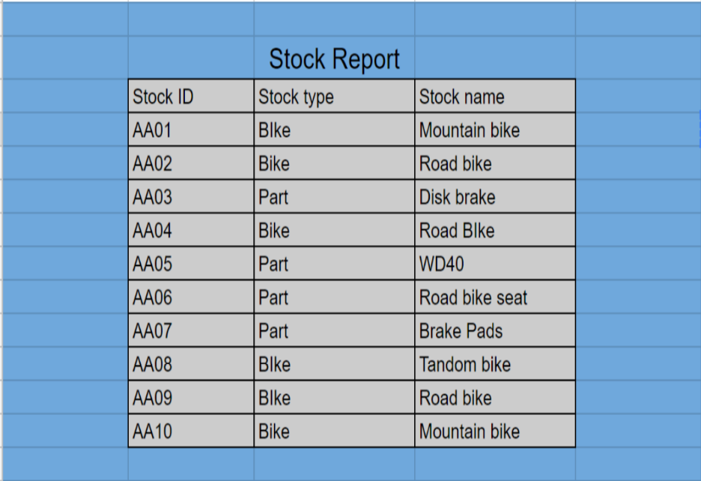

Damage Report/Maintenance Report

A damage report would be relevant to RR bikes, this would show the damage of all the bikes within the RR shop and what bikes can be used for rental. A stock report is vital to go alongside the damage and maintenance report as then you can order parts to fix bikes which are shown in the damage report.

Financial/Customer Reports

Financial/customer reports these can be combined together into one report so that RR can see the arrears of the customers and collect money. They will also be able to see what the profit is like in the current month. This will help the owners decided how to take the business forward to grow the business and keep them open.  (See figure 2 for example)

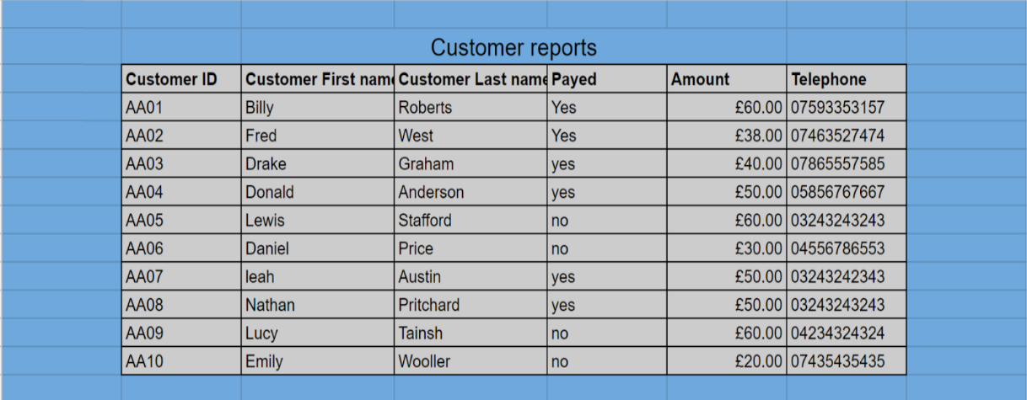

Analysis Report

In an analysis report, you will look at the data you have gathered throughout the year. A SWOT analysis will be created to act upon business strategy so RR can improve the company.

Process Report

Process reports these will help RR to see the profit for the year, using this data they will be able to predict the profits for the next year and be able to set appropriate goals for the business.

Conclusion

In summary RR’s paper based system has many shortcomings. The proposed new computerised database system will help solve many of these downfalls.

Data enquiries are vital to a database likewise management reports are vital to businesses. The useful reports are outlined above and these would enable RR to build an effective business plan and strategy to move forward, to increase profits, performance and productivity.

**Referencing List**

* S. King, (2016), “Financial Reports vs. Management Reports: What’s the Difference?”  
  (<https://www.growthforce.com/blog/financial-reports-management-reports-differences>)
* T. Jackson, (2016), ”The New Definition of Management Reporting”  
  (<https://www.clearpointstrategy.com/new-definition-management-reporting/> ).

**Bibliography List**

* M. [Kolakowski](https://www.thebalance.com/mark-kolakowski-1286589), (2016),”Overview of Management Reporting Systems“ (<https://www.thebalance.com/management-reporting-1286950> ).

D. Sullivan, (No Date) Types of Managerial Accounting Reports  
(<http://smallbusiness.chron.com/types-managerial-accounting-reports-58384.html> ).